Surajit Halder
PRN.24070521509
Sec.B2, Sem.5th
Practical 1
Inline JS:
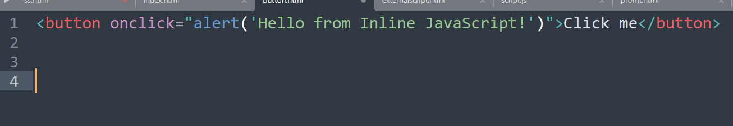
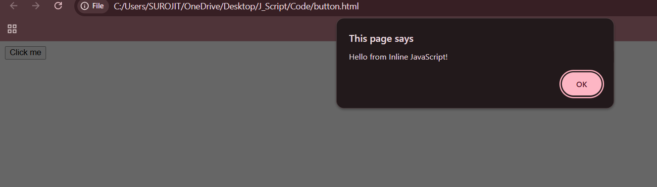
Inner JS:
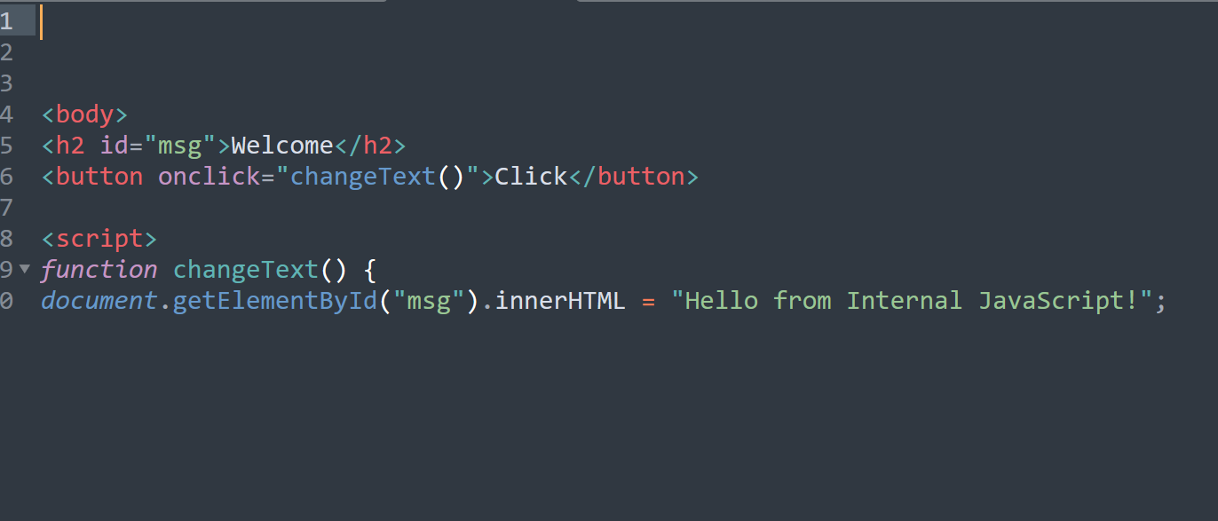

External JS:
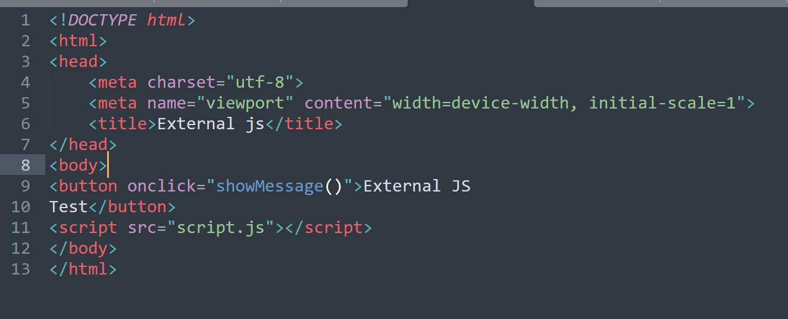
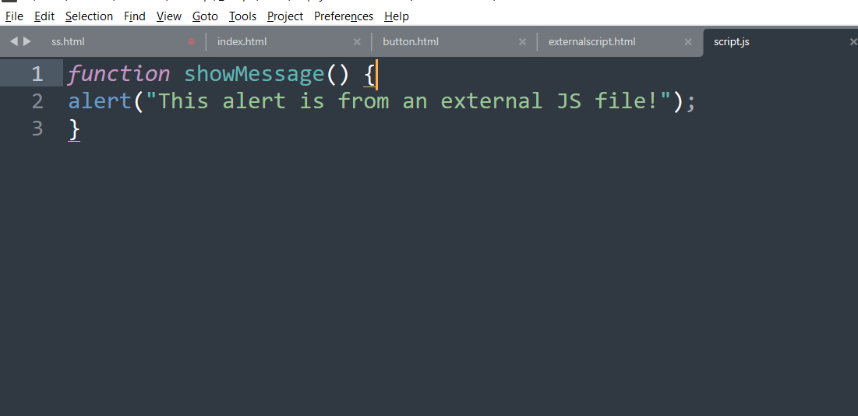

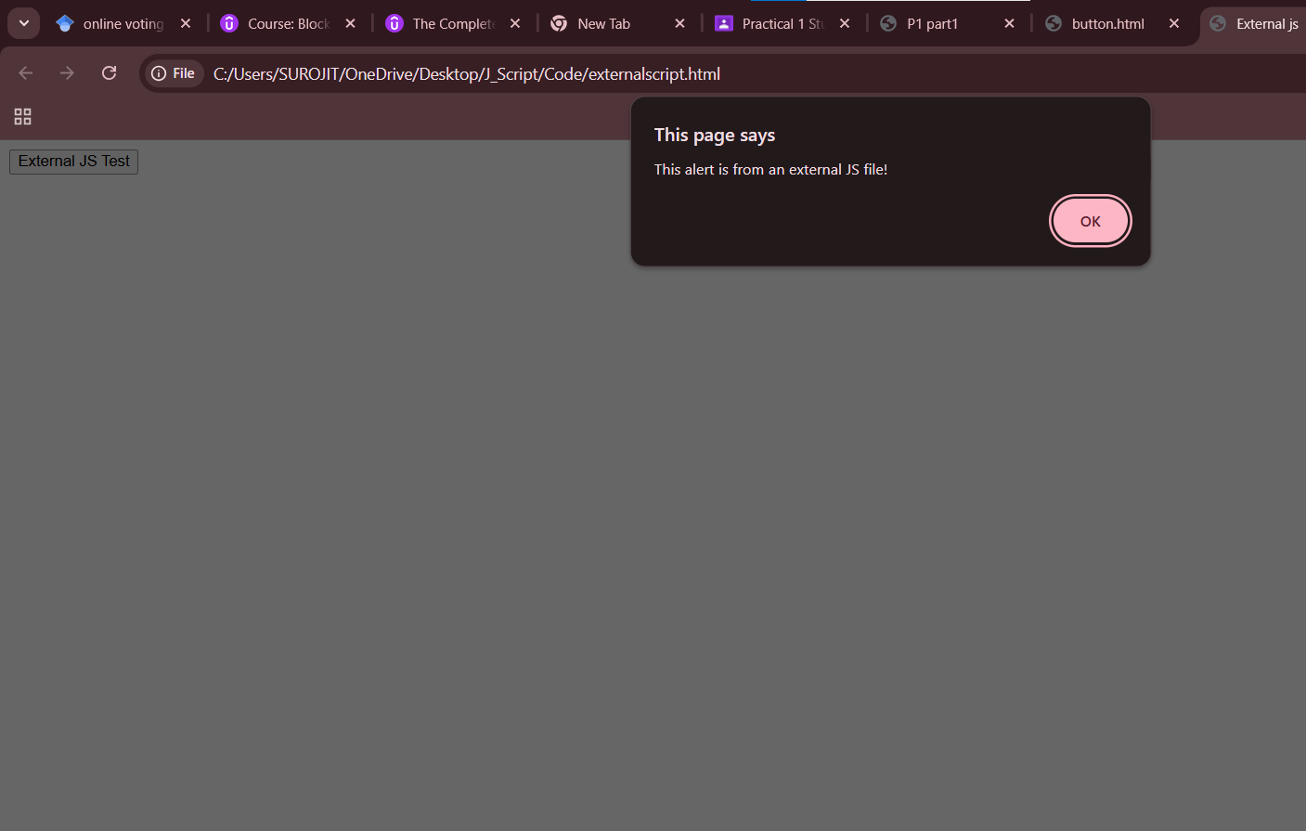
Console:
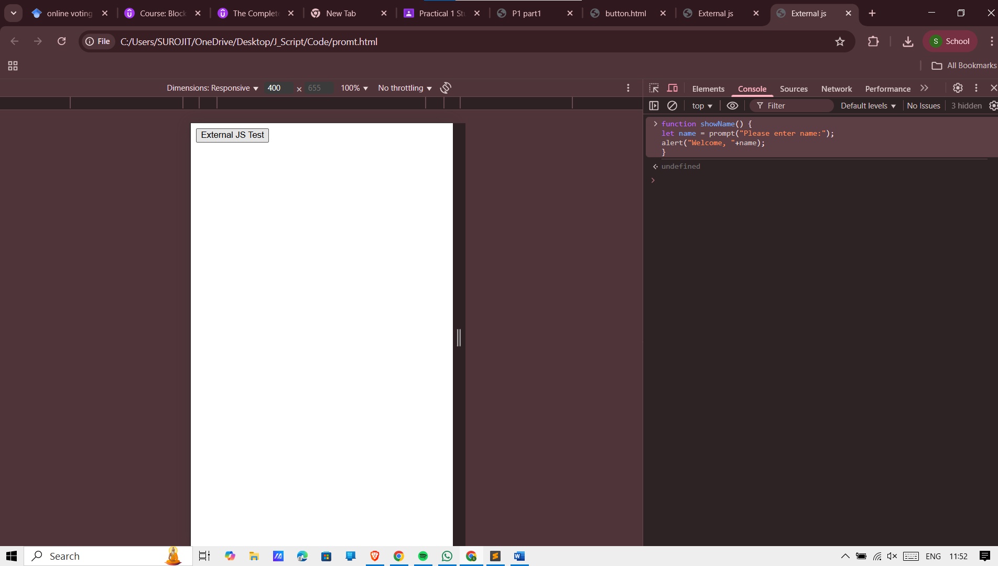

Task 2: Console and DOM Practice
● Add a button.
● On click, log a message to the console and change text in a <p> tag.
